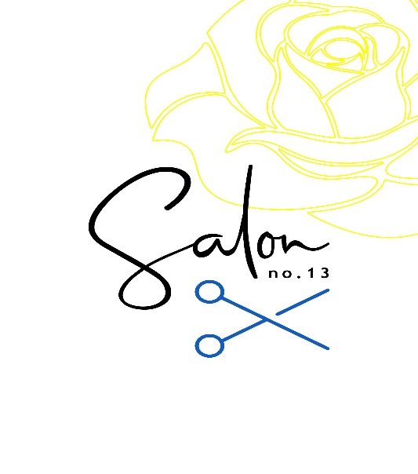
Services & Prices
Cutting & Styling
Prices as of February 2024

 |  | Salon Artistic Director | Senior Creative Stylist | Stylist
Cutting
Ladies  Wet Cut  Cut & Finish  Restyle |  | 49  60  72 | 45  56  68 | 37  47
Men  Dry Cut  Wash & Cut |  | 22  25 | 22  25 | 22  25
Styling
Blowdry  Short  Medium  Long  Hair up from |  | 32  35  39  60 | 32  35  39  60 | 32  35  39  60

