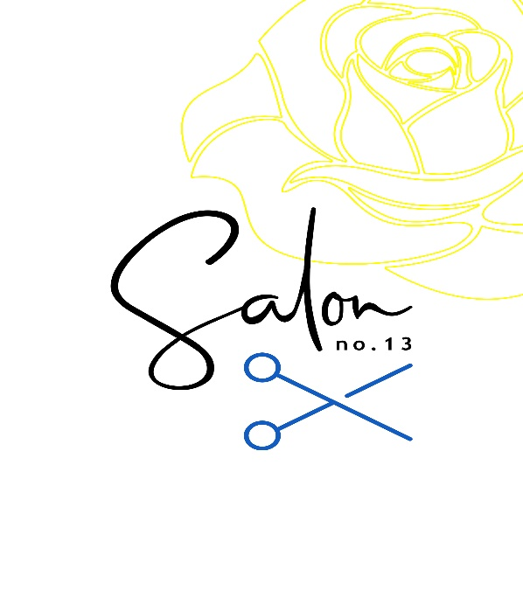Services & Prices

Perming, Treatments and Young Adults

Prices as of February 2024

|  |  |  |  |  |
| --- | --- | --- | --- | --- |
|  |  | **Salon Artistic Director** | **Senior Creative Styist** | **Stylist** |
| **Perming** |  |  |  |  |
| Perms from  (approx price on consultation) |  | **90** | **90** | **-** |
| **Treatments** |  |  |  |  |
| Olaplex bonder  Olaplex 2 in 1  Moisture/Repair  NanoKeratin Short  NanoKeratin  Long |  | **33**  **20**  **15**  **135**  **170** | **33**  **20**  **15**  **135**  **170** | **33**  **20**  **15**  **135**  **170** |
| **Kids & Young Adults** |  |  |  |  |
| Toddlers  3 -7 Girls  8-11 Girls  12 - 16 Girls  3-9 Boys  10 – 15 Boys |  | **-**  **-**  **-**  **-**  **-**  **-** | **12**  **19**  **27**  **36**  **16**  **18** | **12**  **19**  **27**  **36**  **16**  **18** |
|  |  |  |  |  |

**All Prices include washing and styling if required. Prices are the same for dry cuts.**

**Whilst the salon is child friendly, these prices are only available Tuesday to Friday 10am to 5pm. All children must be supervised throughout their visit. Young adults above the age of 16 are classed as an adult. We do not offer student discount on any services.**