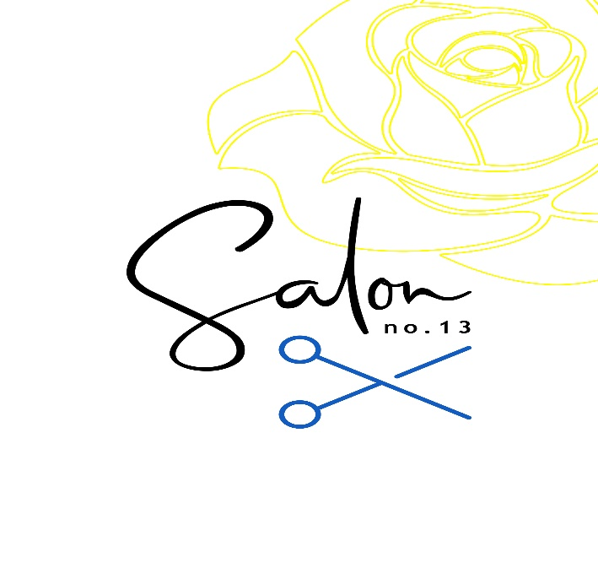
Services & Prices
Colouring
Prices as of February 2024

 |  | Salon Artistic Director | Senior Creative Stylist | Stylist
Semi-Permanent
Full head Gloss |  | 62 | 62 | 50
Permanent
Regrowth  Interim Regrowth (1/2head)  Full Head |  | 62  35  72 | 59  35  69 | 50  35  57
Highlights
Full head  Half Head  T Section  Per Foil (max 15) |  | 120  95  69 | 115  90  66 | 90  70  52
Balayage  Ends Only  Partial (inc face frame, few foils and toner)  Full head (root colour and ends colour) |  | 115  70  170 | 115  70  170 | 95  70
Scalp Bleach  Regrowth  Full head |  | 90  115 | 90  115
Toners  Same Day  Solo Service |  | 35  25 | 35  25 | 35  25

All colour applied to scalp require a skin test 48 hours before an appointment if you’ve never visited us before. All prices above are for colour service only and exclude any cutting or styling. This needs to be booked separately and all colour services must be added to bookings online first. If anything is booked before a colour this doesn’t allow for processing time and may result in your booking being cancelled or rescheduled.

